Health one Version 7.5.0.1836 30/01/2015

- Pregnancy Management Module
We are introducing a completely new way of recording pregnancies that is easy to use but gives the benefit of tracking several pregnancies for each patient and improving population analyses on pregnancies

- Screening Module
- Smoking
- Alcohol
- Others – Exercise - Diet – depression – CVS – Renal – Diabetes – vaccination – colorectal cancer – breast cancer
All of these are for evaluation by users only before we develop them further

- Chronic Disease Mediforms now available from the trends tab
- Chronic Kidney Disease – Calculates eGFR + Creatinine clearance + GFR/ACE risk
- Qrisk Cardiovascular Risk assessment
- Framingham CVD Risk updated to 2009 changes

- Drug Module
- Blank line – We have the ability to add blank lines to teh repeat list for visual effect
- Blank line – we can now add blank lines to the Kardex reports (nursing homes)
- Changes to Kardex and DrugTake reports – if the letter C is added to the end of the report name then the report takes the repeats AND the Current meds. Oherwise repeats only
DrugTake(xxx). takes only repeats and DrugTakeC(xxx) takes repeats and current.
Kardex(xxx) takes only repeats and KardexC(xxx) takes repeats and current
- Disease sets Function to export and import disease sets
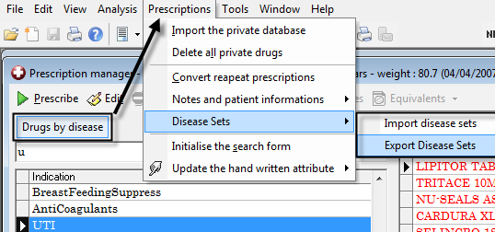

- Escript – functionality to export prescription via Web service to local Pharmacy direct. This is in Pilot phase for the moment
- Stopped drug causes print problem if it’s in the repeats with a Repeat by of more than 1 month –fixed

- Lab results – We have added the following functionality
- allow to directly integrate all normal results except coop messages
- Don’t give coop “priority” an abnormal flag – don’t give “haemolysis” an abnormal flag

- Miscellaneous
- Messaging – add “myself” to the drop down messaging list
- Dictionaries – term “third party consultation” added
- Several other terms either renamed or added
- Billing: - Analyses can be filtered by “invoice date” or “payment date” or both.
- Family Tab – Can view both DOB and Mobile phone of relatives by option
- Invoice – if entered to say a sequence now works

